Bootstrap

https://www.thredup.com/women?department_tags=women

Grid system

<Container fluid>

<Row>

<Col md={6} lg={7}

Estilos de boostrap

**https://getbootstrap.com/docs/5.0/content/images/**

Ejemplo :

<p className='text-primary'>.text-primary</p>

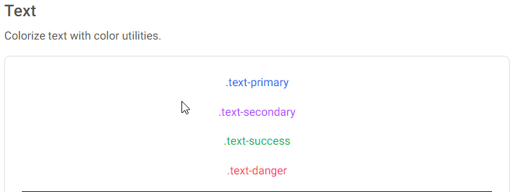

## PASOS PARA USAR BOOTSTRAP:

|  |  |
| --- | --- |
| 1.-INSTALAR BOOTSTRAP, | 2.- IMPORTAR LOS COMPONTES |
| <https://react-bootstrap.github.io/getting-started/introduction/>  npm install react-bootstrap bootstrap | import Button from 'react-bootstrap/Button'; |
| 3.- IMPORT SHEETS | 4.- IMPORT Sass |
| Importar en app.js[import 'bootstrap/dist/css/bootstrap.min.css';](https://react-bootstrap.github.io/getting-started/introduction/" \l "stylesheets) OR CDN  <link  rel="stylesheet"  href="https://cdn.jsdelivr.net/npm/bootstrap@5.2.0-beta1/dist/css/bootstrap.min.css"  integrity="sha384-0evHe/X+R7YkIZDRvuzKMRqM+OrBnVFBL6DOitfPri4tjfHxaWutUpFmBp4vmVor"  crossorigin="anonymous"  /> | In case you are using Sass the simplest way is to include the Bootstrap’s source Sass files in your main Sass file  /* PARA INCLUIR EN src/App.scss */  @import "~bootstrap/scss/bootstrap";  /* PARA INCLUIR EN src/index.js or App.js file */  import './App.scss'; |
| 5.-CUSTOMIZED BOOTSTRAP | 6 importar custom.scss |
| Add the following code to new file custom.scss /* make the customizations */$theme-colors: ( "info": tomato, "danger": teal); Luego incluir bootstrap  @import "~bootstrap/scss/bootstrap"; | /* The following line can be included in a src/App.scss */  @import "custom"; |
| 7.- instalar en react : |  |
| The used package now is **sass**!  npm i -g sass or npm i sass --save-dev |  |

|  |
| --- |
| Grid de columnas y tablas  https://getbootstrap.com/docs/5.0/layout/containers/ |
| https://getbootstrap.com/docs/5.0/layout/columns/ |
| Funcionamiento del grid de bootstrap:  Componente Row-Col, ejemplo:  para xs 1 columnas per row y 12 espacios del grid de ancho  para sm 2 columnas per row y 6 espacios del grid de ancho  para md 3 columnas per row y 4 espacios del grid de ancho  <Row xs={1} sm={2} md={3} lg={4} xlg={6} className="g-3">  <Col className="product-margin" xs={12} sm={6} md={4} lg={3} xlg={2} |

|  |
| --- |
| Instalar font awesome_ bajar y setear |
| https://fontawesome.com/v4/get-started/ |

Project Page: tome en cuenta projecto Shooping cart

|  |  |
| --- | --- |
| Page contacto | <https://5studios.net/themes/dashcore3/blocks/contact.html> |
| Dashboard Principal | https://5studios.net/themes/dashcore3/shop/ |
| NavBar | https://5studios.net/themes/dashcore3/blocks/navbar.html |
| Cart | <https://5studios.net/themes/dashcore3/shop/cart.html>  https://mdbootstrap.com/docs/standard/extended/shopping-carts/  https://cssauthor.com/free-bootstrap-shopping-cart-templates/ |
| CheckOut confirmation | https://5studios.net/themes/dashcore3/shop/checkout-confirmation.html |
| Forms | https://5studios.net/themes/dashcore3/components/form-controls.html |
| Contact us Page | https://5studios.net/themes/dashcore3/contact.html |
| About | https://5studios.net/themes/dashcore3/about.html# |
| Sliders | https://5studios.net/themes/dashcore3/blocks/slider.html |
| Select theme | https://5studios.net/themes/dashcore3/index.html |
| footer | https://5studios.net/themes/dashcore3/shop/checkout-confirmation.html# |
| Admin | https://5studios.net/themes/dashcore3/blocks/navigation.html |

|  |
| --- |
| Implentar carrousel:  https://www.youtube.com/watch?v=_dtLlRRqgrA&ab_channel=Emprinnos |

Second Page

|  |  |
| --- | --- |
| footer | https://5studios.net/themes/dashcore3/automate-social.html# |
| icons | https://react-icons.github.io/react-icons |
| Header |  |
| Pricin |  |
| Custom colors | https://5studios.net/themes/dashcore3/components/color.html |
| PhotoView2 | https://5studios.net/themes/dashcore3/corporate.html |
| Path to succes | https://5studios.net/themes/dashcore3/app-landing.html |
| PhotoView1 | https://5studios.net/themes/dashcore3/payment-services.html#! |
|  |  |
|  |  |